Nithin S
221IT085

IT150 Lab Assignment 10

Q1.. Write a Java program demonstrating the concept of simple inheritance as shown below

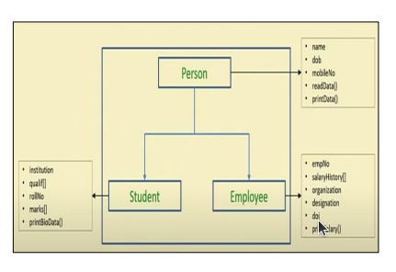

Code
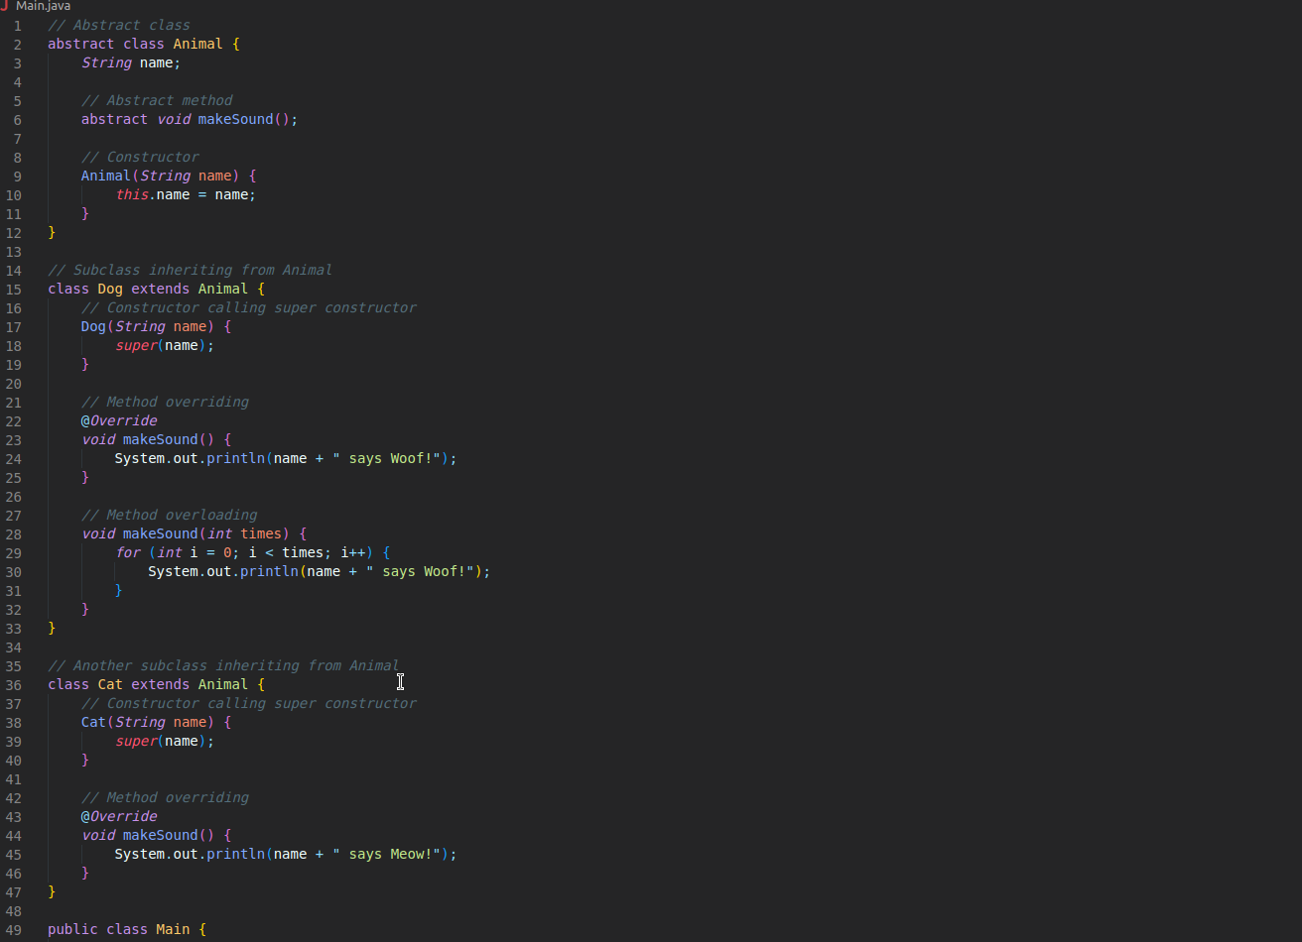
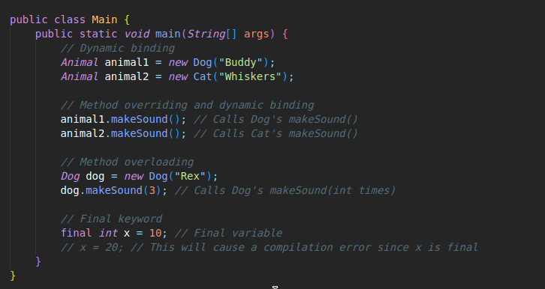

OUTPUT

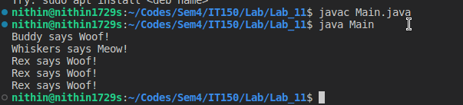

Q2.Write a Java program (use Inheritance) demonstrating the concept of :
a. Constructors
b. Method overriding
c. Method overloading
d. usage of super keyword
e. Dynamic Binding
f. Abstract Class and abstract method
g. Final Keyword

Code

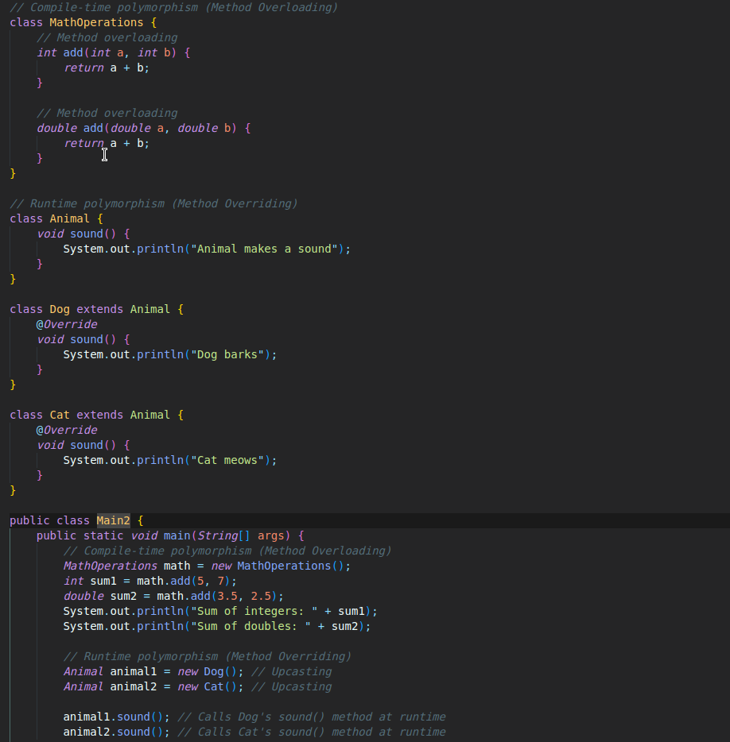
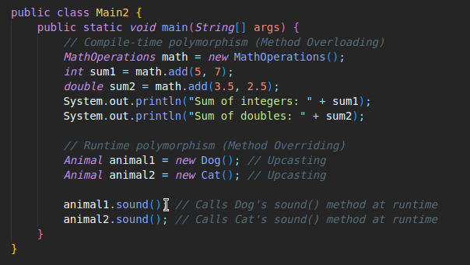
OUTPUT

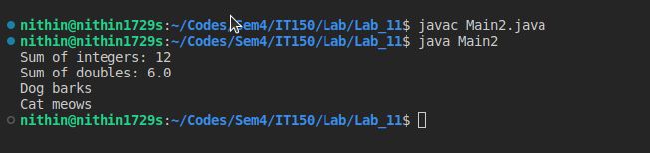
Q3.Write a Java program demonstrating the concept of compile time polymorphism and runtime
polymorphism.

Code
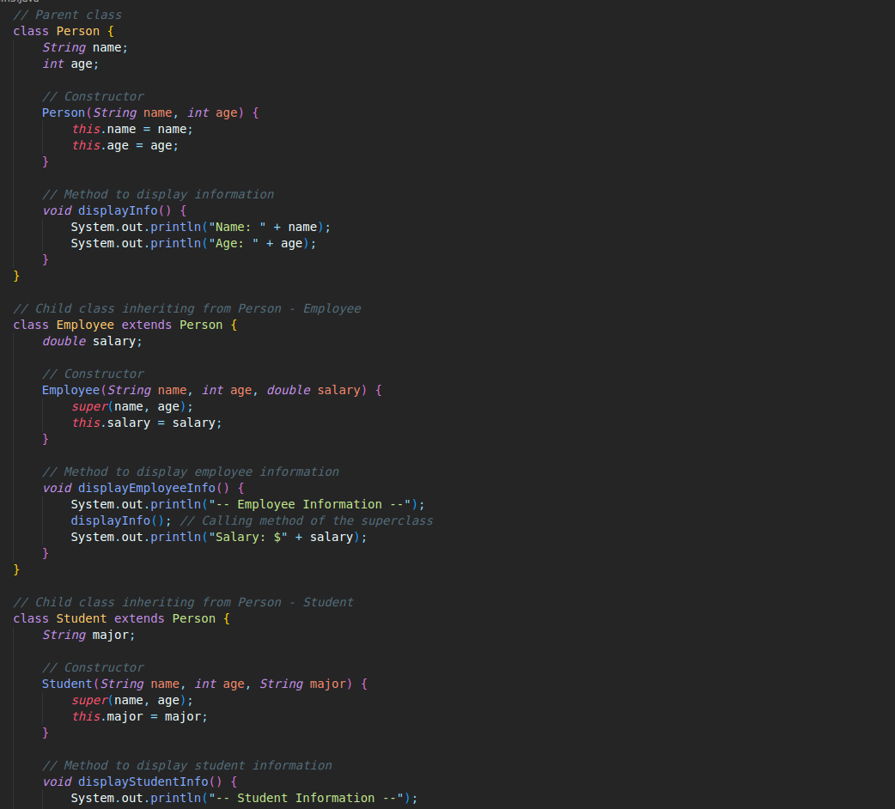

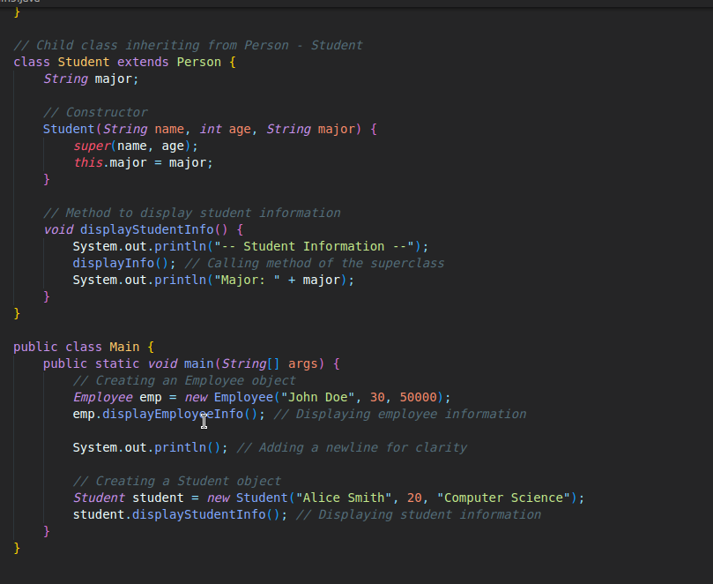

OUTPUT

